

`

TOM Integration
Interface Specification
On
Shelf Edge Label Range and Display information from SR to IDS

[S039]

Project BEN Code: | W60416
Author: | Prasanth Dukaram
Date: | 22/05/2007
Version: | 1.2
Status: | Draft
Modified By: | Prasanth Dukaram
Reviewed By: | Andrew Barker

Change Record

Author | Date | Version | Change Reference, description
Prasanth Dukaram | 18-05-2007 | 0.1 | Draft
Prasanth Dukaram | 21-05-2007 | 1.0 | Review Comments from Andy Incorporated
Prasanth Dukaram | 22-05-2007 | 1.1 | Amended Spec to update specific requirement in Section 2.1
Prasanth Dukaram | 04-06-2007 | 1.2 | Updated the Source Message Schema to include detailrectype on both the files

Reviewers

Name | Position
Andrew Barker | Engagement Architect

At least one reviewer is required.

Sign-Off

By signing this form, I understand and agree with the contents of this document.

Business Owner/Customer | Andrew Barker
Position | Engagement Architect
Signature | <Physical signature or via email approval>
Date | dd/mm/yyyy (<version signed off>)

Distribution List

Name | Date of Issue | Version
Andrew Barker
John Cowper
Jon Braggs
David Onyett
Venkateswara Rao
Mary Welch

Document Source
DocShare: UK IT/TOM Integration/Shared Documents

Related Documents

A complete interface specification requires three documents- an Interface Specification, an Information Architecture Context diagram, and a Mapping spreadsheet. This section identifies these documents plus other documents as appropriate.

Information Architecture Context diagram

Mapping spreadsheet
S039 – SEL Range and Display from SR to IDS Mapping 0.1.xls
Table of Contents
1 Introduction 5
1.1 Purpose of Document 5
1.2 Background 5
1.3 Scope 5
2 Description and Requirements for the End-to-End Interface 6
2.1 Description of the End-to-End Interface 6
2.2 Architecture 6
2.3 Requirements of the End-to-End Interface 6
2.4 Non-Functional Requirements of the End-to-End Interface 7
3 Processing Required in the Extract Stage of the Interface 8
3.1 Scope 8
3.2 Source Message Schema 8
3.3 Message Transport Details 9
3.4 Naming and Configuration 9
3.5 Environment and Security Context 10
3.6 Non-Functional Requirements 10
4 Processing Required in the SSIS Stage of the Interface for IDS 11
4.1 Scope 11
4.2 Package Overview 11
4.3 Data Validation 11
4.4 Filtering 11
4.5 Mapping 11
4.6 Target Message Schema 11
4.7 Message Transport Details 12
5 Testing Deliverables 14
6 Deployment 15
7 Assumptions and Outstanding Issues 16
7.1 Assumptions 16
7.2 Outstanding Issues 16
Appendix A Volumes 17
Appendix B Glossary 18
Appendix C Document Control 19

Introduction

Purpose of Document
The purpose of this document is to describe the interfacing requirements w.r.t Shelf Edge Label Display and Range Indicators data from the Store Range (SR) to Integration Data Store (IDS). The document is of a sufficiently technical in nature to allow a developer to build an actual interface. Additionally the document contains detail that might sit logically within a Technical System Design (TSD) document, but is contained here for expediency. There is therefore no associated TSD for this interface.

This interface is for US and Turkey implementation.

Background
In Tesco Operating Model program, there is requirement to bridge the functionalities of enterprise applications including IKB, PP and Store range. To achieve this functionality, high level process flow architecture has been designed and approved by Tesco’s Enterprise Architecture team. As part of this process flow architecture there is a set of interfaces that has been identified to be developed for IDS and store range system
As part of the process of managing Space, Range and Display activities in store it is important to identify that the store has accurately completed all space range and display activities. Store range receives the Shelf Edge Label information from IKB (JDA) [Interface 78]. IKB sends all the planograms for a store even if one of the planogram is changed. Store range will process the data and give only the changes for the product on store information on the range and display indicators to the external systems. This data is required by Storeline which is catered by the interface C023

Scope
The Interface Specification covers:

- audit requirements across the interface
- security requirements across the interface
- timing/frequency requirements or constraints
- support requirements
- archiving
- the data format to be used for the interface at each stage (e.g. xml messages)
- the normal processing required at each stage
- recovery from failure required at each stage
- volumes.

Note that it is Tesco strategy to avoid placing any business logic in integration layer processing.

Description and Requirements for the End-to-End Interface

Description of the End-to-End Interface
This interface extracts range and display indicators for a product on a store to be printed on the shelf edge labels from Store range system as a flat file and uploads it in the IDS using SSIS. The data is a delta upload in nature. It is application’s responsibility to provide the deltas to integration layer.

All the data in SKUItemInStore will be loaded to the table by Commercial interfaces. This interface will just update the rows with the SEL Range and Display Indicator values on the existing rows of the table. If the Store/Product combination does not exist in the SKUItemInStore table, the failed rows should be gathered in a error log file to be reported. This interface should not modify any other values on the table.

The batch extract would initiate the Sql Server Integration service package. The package would read the flat files for SEL Range Indicators and SEL Display Indicators from SR’s outbox and transform it to the target schema on the IDS through common form. The table which will be populated is SKUItemInStore on IDS.

Architecture
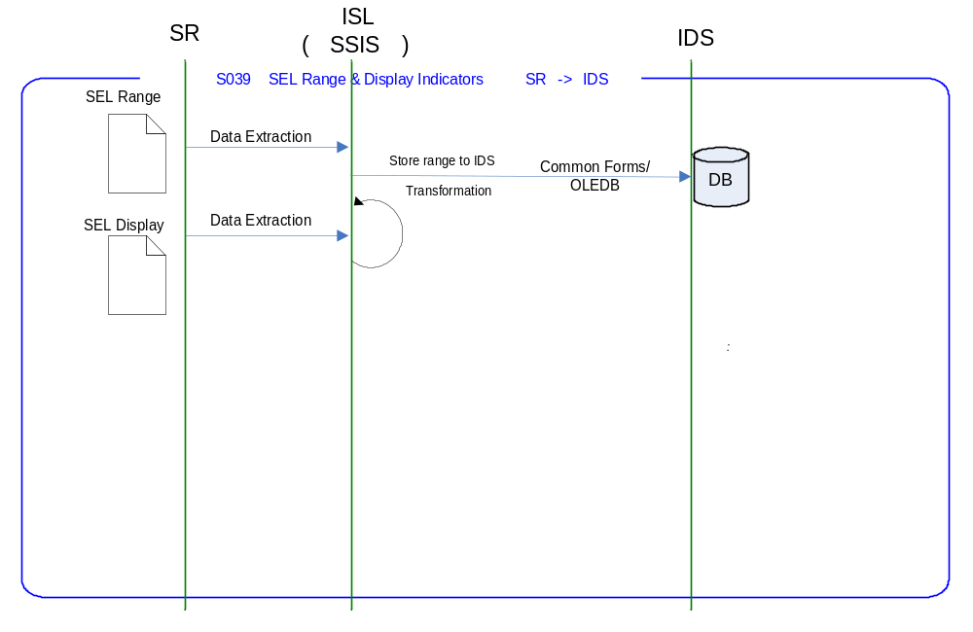

Requirements of the End-to-End Interface

The interface will run once a day, on scheduled basis, and consists of a SQL Server Integration Services package that extracts data from the Store range in the form of flat files, and transforms it into an target schema format and transfers it into the target table (SKUItemInStore) of IDS through Common Forms

The interface will make use of the audit and traceability components that are being developed as part of the Operational Framework stream. These components will be pluggable, and will be useable from BizTalk, RTI and SSIS. At the time of writing (2007-03-01) the components are in design. Although not ready for use, they are included on the Information Architecture Context diagram where their functionality is required. Developers should put a ‘placeholder’ in their code / configurations as appropriate.

Non-Functional Requirements of the End-to-End Interface

Audit Requirements | The interface will use the components provided by the Operational Framework to satisfy audit requirements.
Security Requirements | The interface executes within a secure private domain. There is no additional security considerations required.
Timing/Cut-off Constraints | To be finalised.
Performance Requirements | The interface should be capable of extracting data from SR through SSIS Service layer delivering the resulting data into target schema format of IDS. These processes should occur before the identified cut-off time. The interface should run on scheduled batch basis.
Reliability and Availability Requirements | The interface-run should be atomic in nature. Appropriate mechanisms should be in place to raise/alert appropriate parties (TBD).
Scalability Requirements | No Scalability requirement. The requirement is to deliver a single extract. It is anticipated that the volume of data transferred will continue to remain within the capability provided by this implementation.
Operational Support Requirements | The successful delivery, failure in the creation of the extract, and failure in message transport, must be recorded by the Integration Management Operational Framework (IMOF). In the event of failure, an alert should be raised. Alerts will be monitored by HSC Operations and passed to support as appropriate. (Refer to 8.3 Outstanding Issues).
Likelihood of Change Requirements | Since this interface is developed on assumptions There will be a change for this interface is expected.
Cultural/Global Consideration Requirements | Although multi-byte character set support is not required for US or Turkey, the interface will support multi-byte character sets through integration.
Legal Requirements | N/A
Compliance To Standards Requirements | No compliance exceptions.

Processing Required in the Extract Stage of the Interface

Scope
A scheduled batch job/s runs, at a pre-configured time, to extract the SEL Range and Display indicators data from the Store range Outbox by executing SQL server Integration Services package. The returned data-set will be transformed to the target table format within SSIS package and uploaded in IDS database through common forms.

If either of the two input files is missing or corrupted, the process should stop raising an error. This should include the validation of header and trailer.

After successful completion of data extraction, the files will be moved to the archive folder of the source application, in this case it will be Store range

Source Message Schema
The data for this interface resides in two flat files at Store range Outbox.

SEL Range File: SR_SELRange_YYYYMMDDHH24miss.txt (TBC)

Field | Description | Format
Header Record |  | Len 84
HeaderRECTYPE | Value ‘0’ | Char(1)
RUNDATE | YYYY-MM-DD | Char(10)
RUNTIME | HHMMSS | Char(6)
FILLER |  | Char(67)
Detail Record |  | Len 84
DetailRECTYPE | Value ‘1’ | Char(1)
Store Number | Retail Outlet number of Store | Integer(10)
Product Number | Tesco item number of base product | Char(25)
Display Group |  | Char(30)
Planogram ID |  | Char(16)
Range Indicator | 0 = Not In Range, 1 = In Centrally proposed range, 2 = In Local Range | Char(1)
Product Status | 0 = Standard, 1 = New, 2 = Discontinued | Char(1)
Trailer Record |  | Len 84
TrailerRECTYPE | Value ‘9’ | Char(1)
RECCOUNT |  | Integer(9)
FILLER |  | Char(74)

SEL Display Indicators: SR_SELDisplay_YYYYMMDDHH24miss.txt (TBC)

Field | Description | Format
Header Record |  | Len 58
HeaderRECTYPE | Value ‘0’ | Char(1)
RUNDATE | YYYY-MM-DD | Char(10)
RUNTIME | HHMMSS | Char(6)
FILLER |  | Char(41)
Detail Record |  | Len 58
DetailRECTYPE | Value ‘1’ | Char(1)
Store Id |  | Integer(10)
Product |  | Char(25)
Number of facings wide |  | Integer(10)
Number of default labels |  | Integer(10)
Multi located indicator |  | Char(1)
Shelf ready packaging |  | Char(1)
Trailer Record |  | Len 58
TrailerRECTYPE | Value ‘9’ | Char(1)
RECCOUNT |  | Integer(9)

Message Transport Details

Feature | Specification | Additional Information
Source System Name | SR
Source Platform / OS | Windows 2003 Server
Source Physical Location | SQL SERVER 2005
Source Underlying Data Storage Technology | RDBMS
Target System Name | --
Target Platform / OS | Windows 2003 Server
Target Physical Location | --
Target Underlying Data Storage Technology | In Memory
Transfer Function | HTTP (Put/Post) □  HTTPS (Put/Post) □  Message Queue □  FTP □  File Drop(Windows) □  (XCOM) □  SSIS ☑
Data Format. | XML □  Delimited □  Positional ☑  RDBMS □
Decryption/Encryption | No
Decompression/Compression | No
Transmission Mode | Synchronous □  Asynchronous ☑  Bulk Data □
Real-time/Scheduled Batch | Scheduled Batch
Archiving | There is no requirement to archive the messages.
Logging | Log via the Operational Framework.
Error Handling | Not yet decided  Processing should prevent sending of duplicate messages, unless this occurs during recovery from failure.

Naming and Configuration

SSIS
Package Name: TOM.S039.SRtoIDS.SELRangeAndDisplayIndicators.dtsx
SSIS Procedure
Name | S039_UpdateSELRangeandDisplayInd_usp.sql
<Placeholder for other package components/steps>
<Placeholder for other package components/steps>

Environment and Security Context

This section should contain any additional environment specific details deemed necessary. The information will depend on the technologies used by the interface. For example employing BizTalk this section would include details of the host – In-Process Host, Isolated Host, and whether the host was Trusted/Untrusted. For interfaces employing the RTI indicate whether the instruction is Hosted/Unhosted.

Also indicate the account that the process will run under. In projects where the target deployment environment does not exist at the time of writing the interface specification, the information should be added at a later date (but obviously, prior to deployment).

Account details will be included here once we have visibility of the environments.

Non-Functional Requirements

One of the Non Functional Requirement for this interface is, SR to move the files to Archive directory of the Integration Layer. The files to SR will be delivered in the Integration Layer in Inbox of Store range folder. To let IL know that, the files are taken by SR, the files will be moved by SR to the Archive folder on the Integration Layer.

On Integration Layer, directories will look as below

../StoreRange/INBOX
../StoreRange/ARCHIVE

Processing Required in the SSIS Stage of the Interface for IDS

Scope
This section describes the discrete steps within the SSIS package to extract and format data. The target schema is included in this section. This segment will process the data picked from SR and transform into target message schema in Integration layer. The data is then inserted into IDS table (SKUItemInStore).

Package Overview
SSIS extracts the SEL Range and Display data from SR via SQL Server Flat file connection, at a predefined time. In turn, the data is transformed into a target message schema in Integration layer and inserted into the IDS table using common forms through OLEDB Connection.

Data Validation
N/A.

Filtering
There is no filtering requirement.

Mapping
Mapping document will be provided subsequently.

Target Message Schema

SKUItemInStore table structure of IDS V6

Field | Data type | Description
SKUID | Varchar(25)
StoreID | Int
FoodStampInd | Char(1)
WICInd | Char(1)
MeasureOfEach | Numeric(12,4)
MeasureOfPrice | Numeric(12,4)
ShelfFacingsQty | Smallint
MultiLocationInd | Char(1)
PricingUOM | Varchar(4)
PlanogramID | Varchar(25)
ProductStoreStatus | Tinyint
ProductStoreRangeStatus | Tinyint
SELQty | Tinyint
LocalSKUDescription | Varchar(250)
LocalShortSKUDescription | Varchar(120)
LastUpdateDateTime | Datetime

Message Transport Details
For messages destined for IDS (from SR in Integration layer), the following applies.

Feature | Specification | Additional Information
Source System Name | --
Source Platform / OS | Windows 2003 Server
Source Physical Location
Source Underlying Data Storage Technology
Target System Name | IDS
Target Platform / OS | Windows 2003 Server
Target Physical Location | IL
Target Underlying Data Storage Technology | RDBMS
Transfer Function | HTTP (Put/Post □  HTTPS (Put/Post) □  Message Queue □  FTP □  File Drop (Windows) □  (XCOM) □  RTI File Adapter □  SSIS ☑
Data Format | XML □  Delimited □  Positional □  RDBMS ☑
Decryption/Encryption | No
Decompression/Compression | No
Transmission Mode | Synchronous □  Asynchronous ☑  Bulk Data □
Real-time/Scheduled Batch | Scheduled Batch
Archiving | N/A
Logging | Log via the Operational Framework.
Error Handling | Not yet decided

Testing Deliverables
This section should contain a list of discrete deliverables. The following table is an illustrative template only. The exact deliverables will depend on the technologies employed in the interface.

Deliverable | Description
TBD <stored proc name> | Stored Procedure
TBD <stored proc name> | Stored Procedure
TBD <service name>
TBD <SSIS package name> | Package
TBD <script name> | Unit Test Scripts. Scripts should be provided to:  - Create databases (including stored procedures).  - populate with the minimum set of test data to satisfy functional requirements  - notes showing how to use scripts and describing the functions tested.
<installer> | Installers as appropriate to the technology being used.

Deployment

Assumptions and Outstanding Issues

Assumptions
ID | Assumption
1. | The input files SEL Range and Display are expected to be available to the IL at the same time
2 | The file names are currently assumed, which is to be confirmed by the Store range team

Outstanding Issues
ID | Issue | To be addressed by
1 | Timings and cut-off constraints need to be defined. Require input from SR | SA
2 | Alert numbers/identifiers are yet to be defined | SA
3 | The design of the IMOF is still being worked and will require retro-fitting to the interface. | IMOF team

- Volumes
- Glossary

Acronym | Term | Description
EAI | Enterprise Application Integration | The process of meeting the data requirements of applications by providing a message based transport from disparate data sources across all forms of enterprise technology.
EAI Layer | Enterprise Application Integration Layer | Refers to the integration services provided to implement EAI. In contrast to the EIA Layer for data services. See below.
EIA | Enterprise Information Architecture | Creation of a strategic single view of data across the enterprise.
Interface | Interface | Many definitions exist for 'interface'. In general, 'interface' refers to the link between a data source and a data target. And there are properties of the interface in this context. However more specifically 'interface' refers to one end of a data link, hence the terms source interface and target interface, and both the source interface and the target interface will have specific properties of their own.
RMS | Retek Merchandising System | Retek Merchandising System is getting installed for TESCO Merchandising operations in US. This system will governs the Merchandising operations; Receive base Master & Transaction data and from other systems and Provide data to next level of operation system as part of Retail systems chain.
PP | Product Position | SQL Server Database provided by Product position which captures the capacity information for the products which are not part of planogram
IKB | Intactix Knowledge Base | SQL Server Database provided by JDA Intactix to maintain Space Planning and Floor Planning data.
IMOF | Integration Management Operational Framework | IMOF is a framework which is pluggable to any Biztalk, RTI and SSIS for alerting, exception handling, defining rules, scheduling etc

- Document Control
Change Record

Author | Date | Version | Change Reference, description
Prasanth Dukaram | 18-May-2007 | 0.1 | Draft
Prasanth Dukaram | 21-05-2007 | 1.0
Prasanth Dukaram | 22-05-2007 | 1.1
Prasanth Dukaram | 04-06-2007 | 1.2

Related Documents

Author | Date | Version | Title

Distribution

Name | Position | Approver/Contributor/Other
Jon Braggs | Enterprise Architect
Andrew Barker | Solution Architect
Mary Welch | Manager – SRD TOM project

